Experiment 8

Student Name: Lakshay Aggarwal UID: 25MCI10047
Branch: MCA (AI/ML) Section/Group: 25MAM-1(A)
Semester: 2-SEM Date of Performance: 31/03/2026
Subject Name: Technical Training - 1 Subject Code: 25CAP-652

- Aim of the Session:

To apply the concept of Stored Procedures in database operations in order to perform tasks like insertion, updating, deletion, and retrieval of data efficiently, securely, and in a reusable manner within the database system.
- Software Requirements:
- PostgreSQL
- pgAdmin
- Windows Operating System

- Objectives of the Session:

Apply stored procedure concepts for database operation.

- Theory:

A Stored Procedure is a precompiled set of SQL statements that is stored inside the database and can be executed whenever required. It is used to perform one or more database operations such as:
- INSERT
- UPDATE
- DELETE
- RETRIEVE / SELECT
Instead of writing the same SQL query again and again, we can create a stored procedure once and call it multiple times whenever needed.
Features of Stored Procedure
- Stored inside the database
- Can accept parameters
- Can perform CRUD operations
- Can return values using OUT or INOUT parameters
- Can include conditional statements like IF, CASE
- Can handle exceptions / errors

- Practical / Experiment Steps:

Step 0: Creating tables and inserting records

Code:

CREATE TABLE Employees (

emp_id INT PRIMARY KEY,

emp_name VARCHAR(50),

manager_id INT,

department VARCHAR(50),

salary INT

);

INSERT INTO Employees VALUES

(1, 'Rajesh', NULL, 'Management', 130000),

(2, 'Meena', 1, 'Sales', 75000),

(3, 'Suresh', 1, 'Finance', 85000),

(4, 'Anita', 2, 'Sales', 55000),

(5, 'Deepak', 2, 'Sales', 58000),

(6, 'Kavita', 3, 'Finance', 60000),

(7, 'Nitin', 3, 'Finance', 62000),

(8, 'Pallavi', 1, 'HR', 72000),

(9, 'Rohit', 1, 'IT', 90000),

(10, 'Snehal', 9, 'IT', 65000);

SELECT * FROM Employees;

Output:

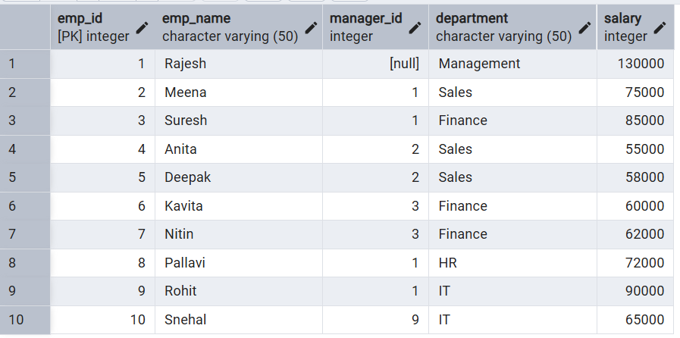

Step 1: Insertion of Record using Stored Procedure.

Code:

CREATE OR REPLACE PROCEDURE add_employee(

p_id INT,

p_name VARCHAR,

p_manager INT,

p_dept VARCHAR,

p_salary INT

)

LANGUAGE plpgsql

AS $$

BEGIN

INSERT INTO Employees VALUES (p_id, p_name, p_manager, p_dept, p_salary);

END;

$$;

CALL add_employee(11, 'Varun', 9, 'IT', 68000);

Output:

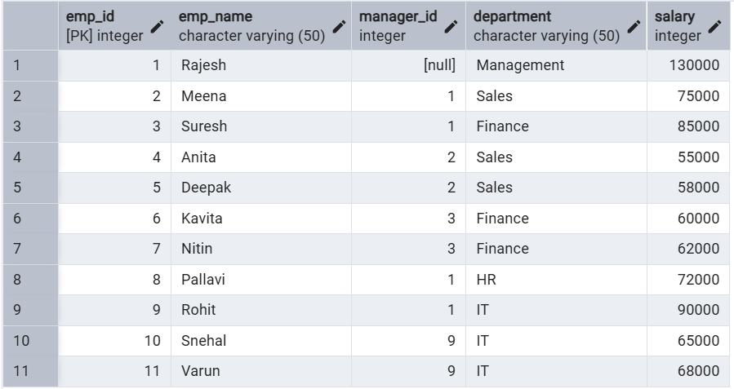

Step 2. Updating the salary of employee using stored procedure

Code:

CREATE OR REPLACE PROCEDURE update_salary_procc(

IN p_emp_id INT,

INOUT p_salary NUMERIC(20,3),

OUT status VARCHAR(20)

)

AS

$$

DECLARE

curr_sal NUMERIC(20,3);

BEGIN

SELECT salary + p_salary

INTO curr_sal

FROM employees

WHERE emp_id = p_emp_id;

IF NOT FOUND THEN

RAISE EXCEPTION 'EMPLOYEE NOT FOUND';

END IF;

UPDATE employees

SET salary = curr_sal

WHERE emp_id = p_emp_id;

p_salary := curr_sal;

status := 'SUCCESS';

EXCEPTION

WHEN OTHERS THEN

IF SQLERRM LIKE '%EMPLOYEE NOT FOUND%' THEN

status := 'EMPLOYEE NOT FOUND';

ELSE

status := 'FAILED';

END IF;

END;

$$

LANGUAGE plpgsql;

CALL update_salary_procc(4, 5000, NULL);

Output:
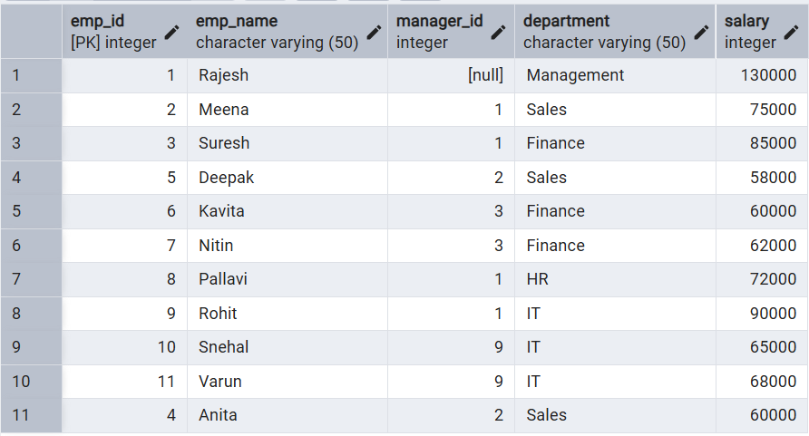

Step 3: Deleting the record of employee using stored procedure

Code:

CREATE OR REPLACE PROCEDURE delete_employee(

p_id INT

)

LANGUAGE plpgsql

AS $$

BEGIN

DELETE FROM Employees

WHERE emp_id = p_id;

END;

$$;

CALL delete_employee(5);

Output:
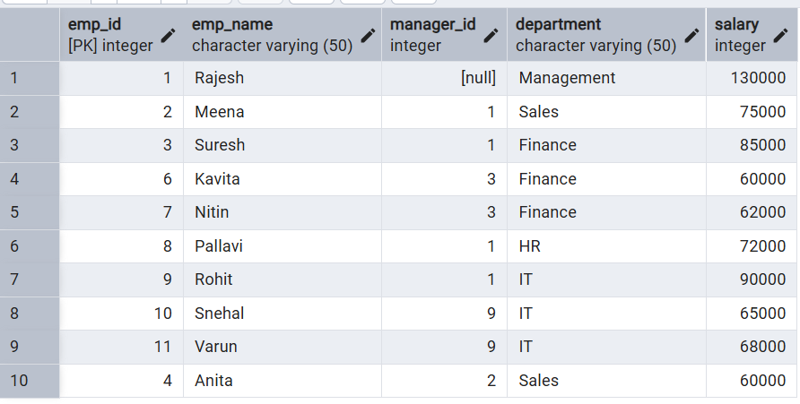

Step4: Retrieving the information of employee

CODE:

CREATE OR REPLACE PROCEDURE get_employee_by_id(

IN p_emp_id INT,

OUT p_name VARCHAR(50),

OUT p_manager_id INT,

OUT p_department VARCHAR(50),

OUT p_salary INT

)

LANGUAGE plpgsql

AS $$

BEGIN

SELECT emp_name, manager_id, department, salary

INTO p_name, p_manager_id, p_department, p_salary

FROM Employees

WHERE emp_id = p_emp_id;

END;

$$;

CALL get_employee_by_id(3, NULL, NULL, NULL, NULL);

OUPUT:

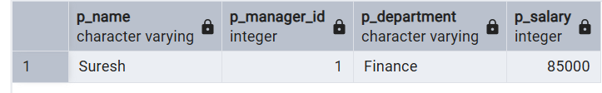

- Learning Outcomes (What I have learned):
- Stored Procedure Understanding: I learned how to create and use stored procedures in PostgreSQL to perform database operations efficiently.
- Practical Database Skills: I understood how stored procedures can be used to manage employee data such as inserting, updating, deleting, and retrieving records in a relational database.
- CRUD Operations Knowledge: I learned how to implement Insert, Update, Delete, and Retrieve operations using stored procedures on the Employees table.
- Parameter Usage: I understood the use of different types of parameters such as IN, OUT, and INOUT in stored procedures for passing and returning values.
- PL/pgSQL Practice: I gained hands-on experience in writing procedural SQL code using PL/pgSQL syntax including BEGIN, END, and SQL statements inside procedures.
- PostgreSQL / pgAdmin Practice: I improved my practical skills in creating, executing, and testing stored procedures in PostgreSQL / pgAdmin.

